Chapter 1 – Overview of Fabric CI/CD
CI/CD represents a set of core principles and best practices that have been widely adopted across the software industry. The goal of CI/CD is to streamline and accelerate the lifecycle of software development. CI/CD focuses on two different aspects of managing the application lifecycle which are Continuous Integration (CI) and Continuous Deployment (CD).
Continuous Integration (CI) is the practice of frequently merging code changes into a shared repository. Each time developers merges their changes, it triggers an automated workflow process to ensure the application code as a whole still works together and can pass validation tests. CI makes it possible to detect bugs and other problems early on. This, in turn, makes it possible to maintain a codebase that's always in a working state and ready to deploy to a production environment.
CI is popular because it allows a team of developers to work on the same application at the same time. CI/CD solves the challenging problem of integrating the work of multiple developers into a shared codebase in an ongoing basis. Once you have designed and implemented a branching strategy, you’ll be able to merge everybody’s changes together in a structured process that maintains code quality while also getting new features into production as quickly as possible.
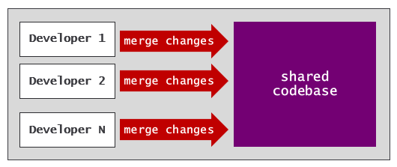
Continuous Deployment (CD) is the practice of automating the deployment of code. Deployment is typically preceded by some type of interactive human approval process. Once changes have been approved, a CD process is automatically triggered to deploy these changes to a target environment.
With CD, you can build automated processes to route the lifecycle of application code through a set of stages. Moving code changes through a set of stages provide opportunities for enhanced testing and approval processes to ensure only high quality code reaches the production environment. The release process in a CI/CD workflow is often built using stages to simulate different environments such as dev, test and prod.
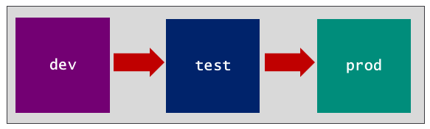

Fabric CI/CD Features
The Microsoft Fabric platform attracts people with different technical backgrounds. For example, there are data engineers tasked with creating and testing notebooks to ingest and transform data to populate lakehouse tables. There are data modelers tasked with building and refining semantic models on top of lakehouse tables. There are report designers tasked with authoring and updating Power BI reports that are built on top of those semantic models. The goal of CI/CD is to enable collaboration which allows all these developers to continually update their part of a Fabric project without stepping on anyone else’s work.

Fabric GIT Integration
The Fabric platform's CI/CD infrastructure starts with its support for GIT integration. Imagine you’re on a team building a data analytics solution based on a workspace that includes a lakehouse, notebook, semantic model and report. Fabric makes it possible to maintain the source code for all four workspace items as a single source of truth in a GIT-based repository. Any changes made to workspace items can be versioned, tracked and compared to other versions.
Fabric's list of supported GIT providers includes Azure DevOps, GitHub and GitHub Enterprise. Microsoft is currently planning to add other popular GIT providers in the future. You can find the most up-to-date information about Fabric's support for GIT providers and their limitations by reading Supported Git providers.
Fabric’s support for GIT integration is enabled at workspace scope. More specifically, you enable GIT integration by connecting a workspace to a branch in a GIT repository. If you navigate to the Git integration tab of the Workspace settings dialog, you can create a connection between the workspace and a GIT repository using a GIT provider such as Azure DevOps or GitHub.
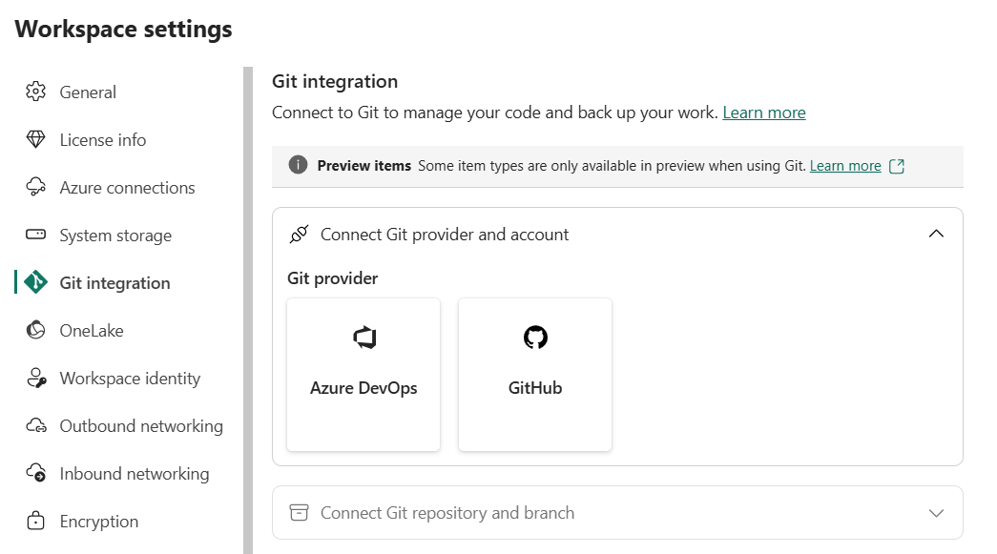
If you select Azure DevOps as the GIT provider, you must then select an Organization, Project, Git repository and Branch. Optionally, you can also include a value for the Git folder setting.
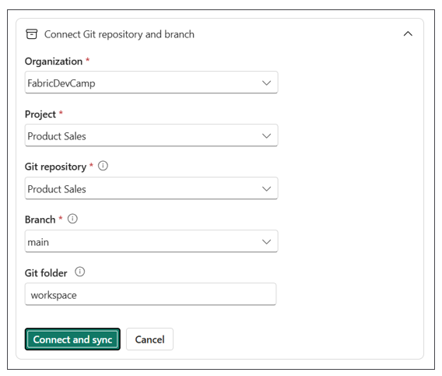
Specifying a Git folder is a best practice because it prevents the source code for workspace items from being stored in the root folder of the target repository. Storing Fabric item definitions in the root directory is problematic because you typically need to add other project files to that repository such as YAML files, Python files and PowerShell files used to implement workflows with CI/CD logic. By configuring a GIT folder, you avoid the confusion mixing the definitions files for workspace items together with other project files.
This examples shown in this article will use Git folder setting of workspace. However, you can use any name you’d like.
Consider the scenario in which you have deployed a data analytics project to a workspace which includes a lakehouse, a notebook, a semantic model and a report. When you first connect the workspace to a GIT repository, Fabric will generate a serialized definition for each workspace item which writes to the target GIT branch as a set of item definition files. After syncing the workspace to GIT, you should see a top-level folder named workspace with child folders for each workspace item.
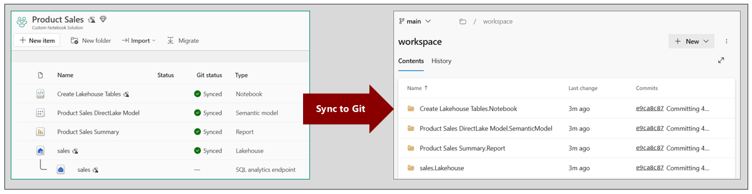
Fabric uses a naming convention for workspace items which includes item display name, a period and the item type in the format of [Item Display Name].[Item Type]. You can see from the previous screenshot that GIT synchronization creates folders using this naming convention for folder names such as sales.Lakehouse and Product Sales Summary.Report.
Fabric GIT integration also makes it possible to sync changes in the other direction. That means you can sync changes from a GIT repository to a target workspace. This makes it possible to initialize an empty workspace from a branch which contains a set of workspace item definitions. As it turns out, initializing an empty workspace from a GIT branch is very common task in the Fabric development process.
Consider a scenario in which you have connected a workspace to the main branch of a GIT repository. The main branch holds item definitions for each workspace item. If you create a new branch from main named feature1, this new branch will initially contain an exact copy of each item definition in main. Now you can create an empty workspace and connect it to the feature1 branch. This triggers Fabric to automatically populate the new workspace by rehydrating a matching set of workspace items.
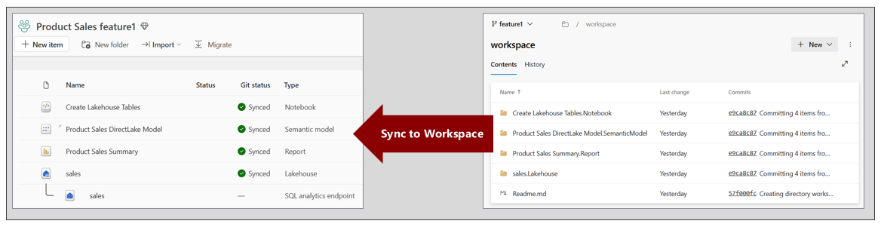
After an empty workspace has been initialized from a GIT branch to serve as a feature workspace, there is often additional work required to prepare that workspace for development purposes. For example, the GIT integration process recreates semantic models but it does not automatically create connections to the underlying datasources.
In a Fabric CI/CD project, it's usually required to set up automated processes which run after GIT synchronization occurs. As you develop these types of automated processes, you need to differentiate between two different kinds of tasks. There are post-deploy tasks and post-sync tasks.
A post-deploy task is a process that must be run only once after an empty workspace has been initialized from a GIT branch. Examples of post-deploy tasks are running ETL jobs to populate lakehouse tables with data and creating and binding connections to semantic models. You can think of these as one-time tasks that are part of the workspace setup process.
A post-sync task is a process that must be run each time after Fabric GIT integration pushes changes from a GIT branch to a target workspace. Examples of post-sync tasks include updating the definition of a semantic model so that it continues to point to a lakehouse in the same workspace.

Team-based Development
Team-based development presents the challenge of merging together the work of multiple developers into a single location. This challenge is addressed by building a continuous integration process with an integration branch. The integration branch is a core concept in the CI/CD development process. This is the place where changes from multiple developers are merged together in a single branch.
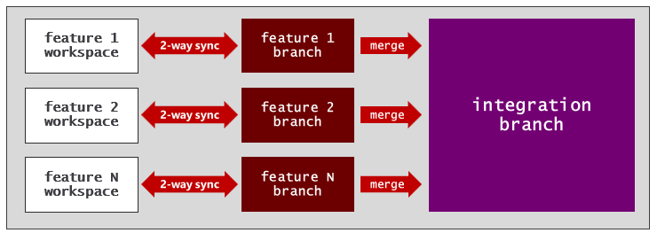
As you design a CI workflow for the development process, one option is to use the main branch as the integration branch.
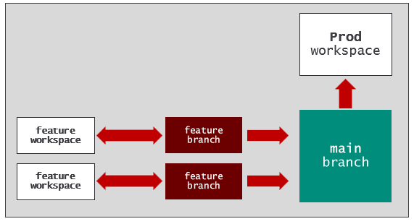
Alternately, you could design a more intricate workflow that uses the dev branch as the integration branch.
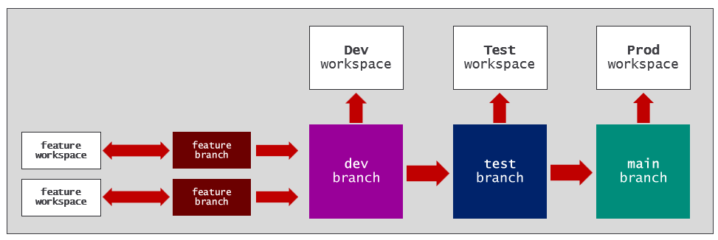
The key point is that you need an integration branch for the development process. However, which branch you chose as the integration branch will depend upon the GIT branching strategy you are using.

Deployment Pipelines
The Fabric platform provides deployment pipelines as a CI/CD mechanism to help manage the lifecycle of workspace items. The key concept behind deployment pipelines is that changes to workspace items are deployed through a set of stages where each stage is implemented using a workspace.
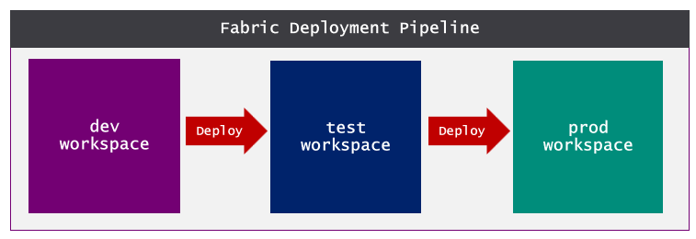
There are two different ways to utilize deployment pipelines in a Fabric CI/CD project. The first option is to keep things as simple as possible and use deployment pipelines as an alternative to using Fabric GIT integration. The second option is to use deployment pipelines together in combination with Fabric GIT integration.
One key audience for deployment pipelines is less technical users. Deployment pipelines were designed to hide many of the low-level details of pushing changes to workspace items across workspaces. Using deployment pipelines instead of using GIT integration is a good choice for organizations that want to avoid the complexity of working with GIT-based repositories and getting everyone on the team up to speed with GIT-based development and branching strategies.
Using deployment pipelines without Fabric GIT integration has a major disadvantage. You lose the ability to track the source code for a Fabric project as a single source of truth in a GIT repository. Not having a single source of truth violates one of the key principles of CI/CD. This makes the option of using deployment pipelines without GIT integration a non-starter for organizations who have embraced CI/CD and all its benefits.
A more viable option for leveraging deployment pipelines in a Fabric CI/CD project is to combine them together with Fabric GIT integration. For example, the development process can be built using feature workspaces and feature branches where changes are merged back to the main branch. In this scenario, the main branch is acting as the integration branch. You can use GIT integration to synchronize changes from the main branch to the dev workspace. A deployment pipeline is used to complete the end-to-end workflow with a CD release process to push approved changes to test and then on to prod.
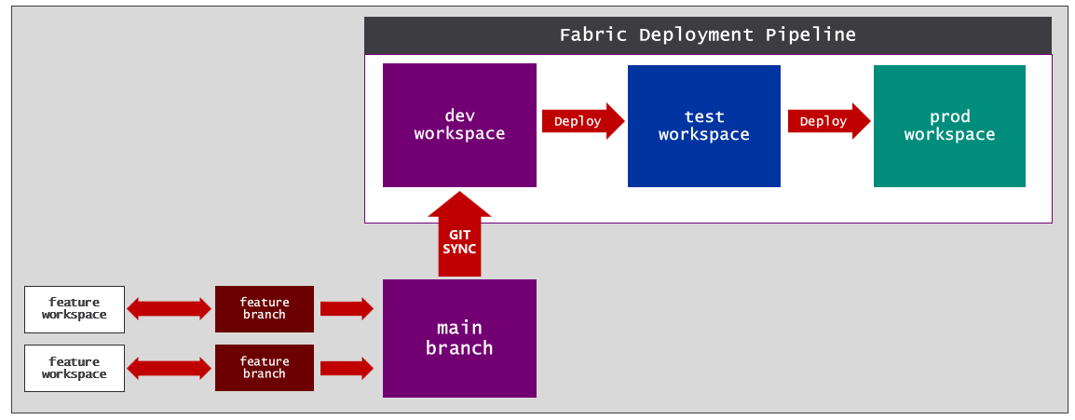
Using deployment pipelines is discussed further in Chapter 3 - Building a Release Process with Continuous Deployment.

Variable Libraries
An essential aspect of the CI/CD lifecycle involves promoting changes through a sequence of stages. The canonical example is a release workflow which moves changes through environments such as dev, test and prod. When you need to test and validate code for a project across multiple environments, it’s essential to find an effective parameterization strategy.
The Fabric platform provides the variable library to assist with parameterization. The variable library is a creatable type of workspace item in which you can define a set of variables. Other workspace items such as notebooks, pipelines, copy jobs and dataflows can be defined to read variable values from a variable library. This makes it possible to avoid hardcoding configuration values that change across environments into your code.
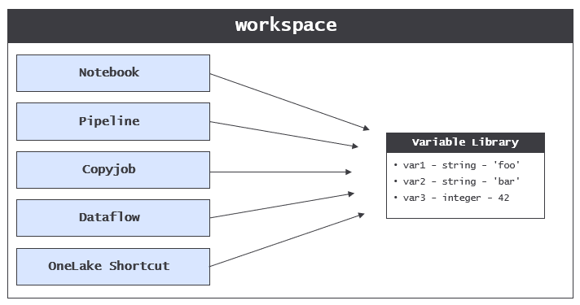
Consider the classic scenario in which you need to build a CD release process that moves changes through a sequence of environments such as dev, test and prod. The problem is that code in different environments must be configured to connect to different databases.
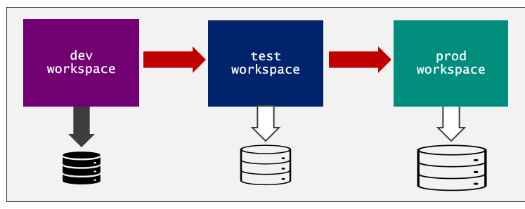
The variable library was created to solve the problem of parameterizing configuration settings across environments. A variable library allows you to avoid hardcoding the configuration settings required to connect to a database. Consider a scenario in which you must write Python code in a Fabric notebook to connect to a SQL database. The thing you want to avoid is hardcoding these configuration settings into your code as literal strings.
database_server = 'devcamp.database.windows.net'
database_name = 'ProductSalesDev'
The obvious problem is that these hardcoded values are specific to one environments. As an alternative, you can leverage a variable library along with its support for parameterization. You can start by creating a new variable library with a display name such as environment_settings. Next, you can add two string variables named database_server and database_name.
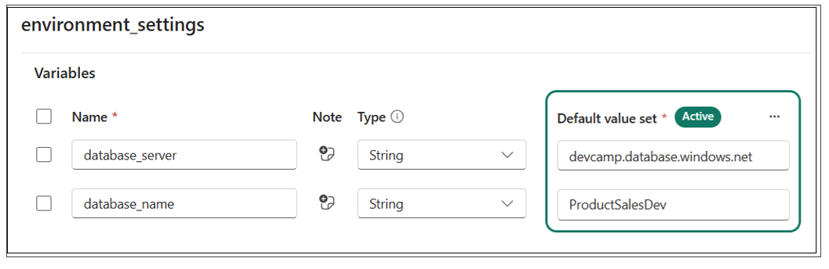
Once you have created the variable library with the two variables, you can remove the hardcoded configuration values from the notebook and replace them with code to read the variable values at run time as shown in the following code listing.
database_server = notebookutils.variableLibrary.get("$(/**/environment_settings/database_server)")
database_name = notebookutils.variableLibrary.get("$(/**/environment_settings/database_server)")
You have learned that a variable library allows you to add variables. That's probably not too surprising. However, variable libraries have another important dimension used to provide parameterization support across multiple workspaces. More specifically, Fabric allows you to extend a variable library using value sets.
A variable library is a collection of variables where each variable is defined with a name, a type and a default value.
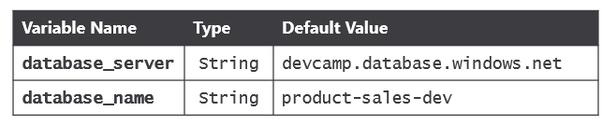
The purpose of a value set is to provide an alternate set of values for each of the variables in the variable library. Consider an example of a variable library in which the default values have been configured for the dev environment. You can extend the variable library by adding a value set for the test environment and a second value set for the prod environment.
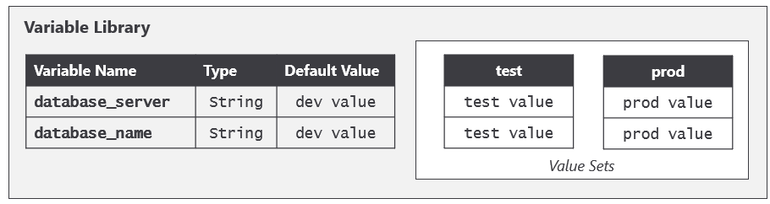
The item definition for a variable library includes variables and values sets. However the item definition does not contain anything to indicate which value set is active. That's because Fabric maintains a separate workspace-level setting that tracks which value set is the active value set for that workspace. That means three different workspaces could each contain a variable library with an identical item definition, yet each workspace can be configured to use a different value set.
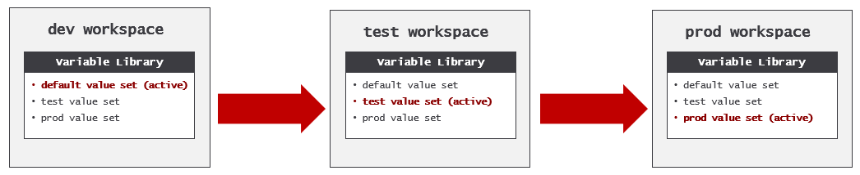

Understanding Workspace Items
Microsoft created Fabric by merging together several existing products including Azure Data Factory, Azure Synapse and Power BI. Microsoft's motivation to merge these products has been to create a unified platform for a wide variety of projects related to data analysis and AI. In this merging process, Microsoft was presented with the challenge of making artifacts, components and features from different products work together. This led Microsoft to design the Fabric platform on top of a core abstraction. This is abstraction is that of the workspace item.
The Fabric platform is built upon a set of backend services known as workloads. For example, there is a Data Factory workload which provides workspace item types used in ETL processes such as DataPipeline and Dataflow. There is a Data Engineering workload which provides workspace item types familiar to Azure Synapse developers such as Lakehouse and Notebook. There is a Power BI workload which provides item types for analytics such as SemanticModel and Report.
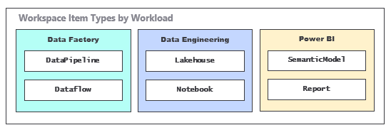
This is just a small sample of the workloads and workspace items types available in Fabric. Currently, Fabric supports over 30 creatable workspace item types and the list is constantly growing. Two years from now there will likely be new creatable workspace item types that nobody even knows about yet.
The core abstraction of the workspace item in Fabric is what allows artifacts from different workloads to behave in a similar manner. The Fabric platform defines the following set of requirements that each workspace item type must implement to fully support all the Fabric CI/CD features.
- Workspace items must support serialization to item definitions for GIT integration
- Workspace items must support deserialization from item definition pulled from GIT branch
- Workspace items must support relations management during deserialization
- Workspace items must support deployment pipelines
- Workspace items must support parameterization using variable library
- Workspace items must support CRUD APIs with item definition for create/update
- Workspace items must support service principal when calling CRUD APIs
Not every workspace item type supports all of these requirements. This can be the case for workspace item types that are still in a preview release. There is also a number of workspace item types that have reached general availability (GA) such as warehouses, but do not yet meet these requirements. While Microsoft is working towards meeting these requirements in all workspace item types, items that do not meet these requirements require various workarounds.

Workspace Item Definitions
Item definitions represent an essential component type in the Fabric platform's support for CI/CD, As you've seen, an item definition can be represented as a set of item definition files. Every item definition requires a common file named .platform which is known as the platform file. The platform file contains metadata such as the item type and display name.
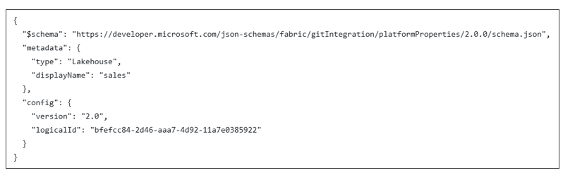
In addition to the platform file, each workspace item type defines its own unique set of requirements for the files required and/or allowed in an item definition. For example, the item definition for a notebook is simple. It just requires one additional item definition file named notebook-contents.py.
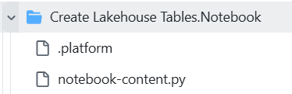
The item definition for a lakehouse requires a different set of files.
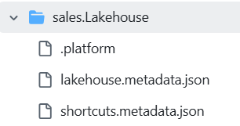
Other types of workspace items can have item definitions that are far more complex. For example, the item definition for a semantic model can include dozens or even hundreds of TMDL files.
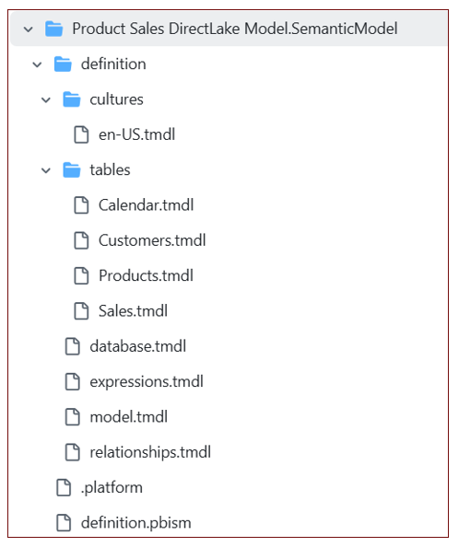
While an item definition with a large number of files is more complicated, it also allow for CI/CD and collaboration in a much more granular fashion. Consider the benefit of splitting out each table in the definition of a semantic model into its own file? It allows one developer to work on the measures in the Sales table while another developer is making changes to the Calendar table. This extra granularity is essential when a team of developers are all working on the same semantic model.
In general, you should gain a basic understanding of item definition files for the workspace items types you are working with in a Fabric CI/CD project. The easiest way to do this is to examine the files in the item definitions that have been written to a GIT branch using Fabric GIT integration support.
Additonal information About Fabric Item Definitions
- Item management overview
- Item definition overview

The Role of the LogicalId
Using Fabric GIT integration, you are able to replicate a set of workspace items across multiple workspaces. As an example, imagine you have created a lakehouse named sales and then you have replicated the lakehouse across three different workspaces. Each workspace contains its own distinct instance of the sales lakehouse. All three item instances share the same type and display name. Yet each item instance has its owns unique id.
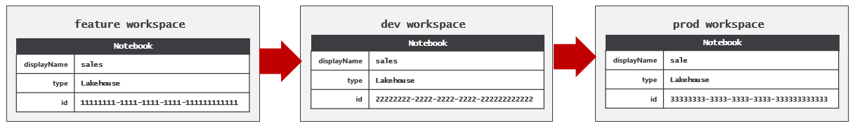
Fabric integration needs a way to track that these three item instances are all associated with a single logical item. This is the reason why Fabric GIT integration includes a logicalId property in the platform file for each workspace instance.
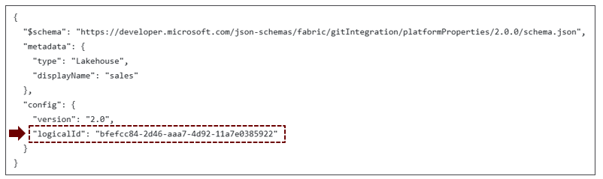
Fabric GIT integration uses logicalId to associate multiple item instances that all represent the same logical item. While each the item instance has a unique id, all item instance share the same logicalid. 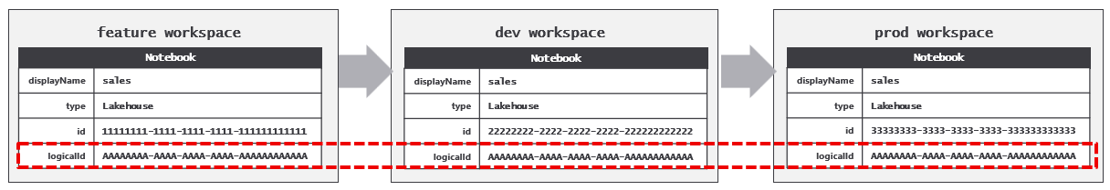
The logicalId is important because it allows workspace items to abstract away item instance ids that are specific to a single workspace. This level of indirection makes it possible for workspace items to automatically resolve their intra-workspace dependencies as part of the GIT synchronization process.
Take an example of a Fabric solution built using a lakehouse, notebook and a pipeline. Assume that the notebook has a dependency on the lakehouse and that the pipeline has a dependency on both the lakehouse and the notebook. After you have built out the solution in the dev workspace, there are three established dependencies between these workspace items.
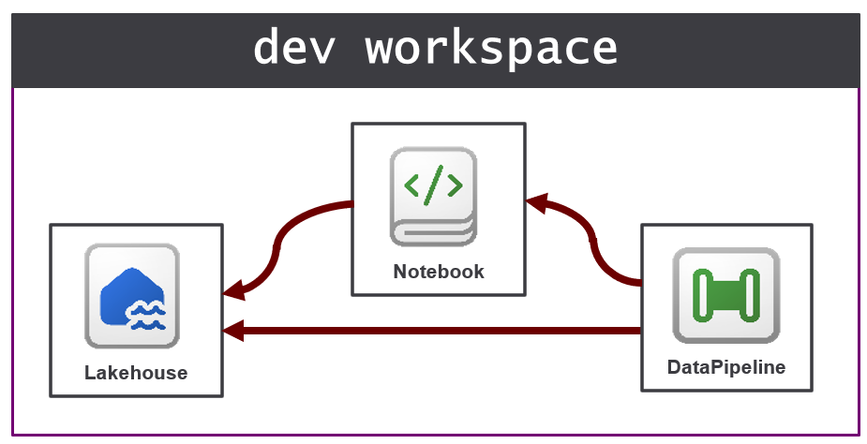
Now think about what happens when you use Fabric GIT integration to replicate these three workspaces items from the dev workspace to the prod workspace. The outcome you do not want is for workspace items created in the prod workspace to retain their dependencies pointing back to an item in the dev workspace. Instead, the desired outcome is for each workspace item to resolve its own dependencies to its related items in the same workspace.
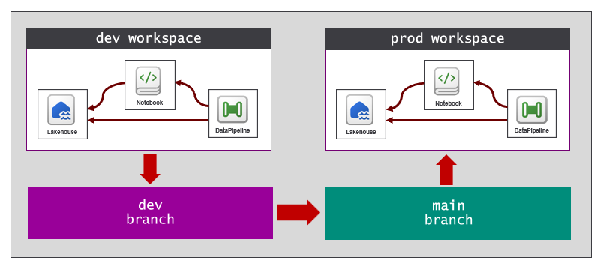
It is not likely that you will ever need to work directly with the logicalId. It is an internal property which is updated and read by Fabric behind the scenes. Fabric automatically generates the logicalId for a workspace item the first time it is serialized to an item definition and written to a GIT branch. As you have seen, workspace items can manage and reestablish relations as they are replicated across workspaces. A key point is that workspace items are designed with behavior to reestablish relations to other workspace items. The implementation of this behavior in workspace items relies on the logicalId to reestablish intra-workspace dependencies.
You should never modify a logicalId value as this is an unsupported action that can lead to unpredictable behavior.

Automating Fabric CI/CD Tasks
Automation becomes an important aspect setting up and managing a Fabric CI/CD project. At the start of a project, there is a need to provision tenant-level items such as workspaces, capacities, connections and deployment pipelines. There will be an ongoing need to create new feature branches, feature workspaces and GIT connections. In some scenarios, there could be a need to automate synchronizing changes back and forth between GIT branches and workspaces. There will is also be a need to update items and their underlying item definitions when writing the code for post-deploy tasks and post-sync tasks.
While many of the tasks for setting up a Fabric CI/CD project can be completed by hand, they can also be automated by writing scripts or programming logic which call public Microsoft APIs. Whenever possible, it's best to build CI/CD processes that don't require manual intervention because that can lead to unnecessary delays and problems caused by human error. The ability to automate an end-to-end setup process using code which can be tested and versioned leads to greater levels of reliability and scale.
There are several public APIs from Microsoft that are used to automate Fabric CI/CD tasks. The Fabric REST APIs provides the ability to create workspaces, connections and workspace items. However, you must use the Azure Microsoft Fabric REST API to create and manage Fabric capacities. The Power BI REST API provides the ability to automate tasks on Power BI items such as refreshing semantic models and binding them to connections. The Tabular Object Model is another powerful API that provides extensive coverage for reading and modifying semantic models.
You can also take advantage of the Azure Data Lake Storage (ADLS) Gen2 APIs and their ability to access content in OneLake. This makes it possible to read and write files in the Files section of a lakehouse. You also might need to automate tasks within a GIT repository such as creating a new feature branch or creating and completing a pull request. To automate tasks with Azure DevOps repositories, you can use the Azure DevOps Services REST APIs. To automate tasks with GitHub repositories, you can use the GitHub REST APIs.
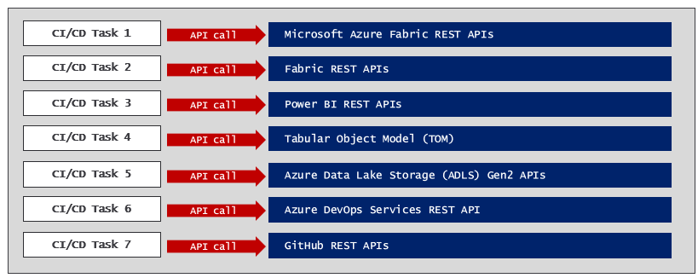
As you can see, there are quite a few APIs that make up the complete landscape for automating tasks in Fabric.
Every call to a Microsoft API executes under the identity of a specific security principal. Microsoft APIs support two types of principal identity which are user principals and service principals. In general, it is a much better choice to execute API calls for CI/CD tasks as a service principal. This is especially true when code executes in a cloud-based environment such as with Azure pipelines or GitHub Actions workflows.
Links to documentation for Microsoft APIs used in Fabric development
- Azure Microsoft Fabric REST APIs
- The Fabric REST APIs
- Power BI REST APIs
- Tabular Object Model
- ADLS Gen2 APIs
- Azure DevOps Services REST API
- GitHub REST API
There are several approaches to automating Fabric CI/CD tasks using public Microsoft APIs. Over the next few sections you will see several different options which make things easier including the Fabric CLI, Semantic Link Labs and Terraform. There is always the option of writing code that calls these Microsoft APIs directly using the programming language of your choice.

Automating Tasks using the Fabric CLI
The easiest approach for automating tasks in Fabric is to leverage the Fabric CLI which hides many of the low-level details for authenticating with Entra Id and executing HTTP requests against Microsoft API endpoints. Fabric CLI also makes it easy to follow the best practice of authenticating as a service principal when developing CI/CD workflows.
Fabric CLI is a is a command-line interface tool that supports both an interactive mode and a scripting mode. The interactive mode allows a developer or workspace administrator to type in and execute a sequence of commands. For example, a developer can use Fabric CLI in interactive mode to quickly create a new workspace and then to create a lakehouse inside that workspace. Fabric CLI also provides commands to load data into lakehouse tables and to automate running notebooks and pipelines which contain ETL logic.
Fabric CLI support for scripting mode can be used to develop CI/CD workflows that run as an Azure pipeline or a GitHub Actions workflow. You can develop Fabric CLI scripts in PowerShell or in Python to create workspaces, capacities, connections and workspace items. Fabric CLI provides an export command to export an item in a workspace to an item definition which consists of a set of item definition files in a local folder. Likewise, Fabric CLI provides a complimentary import command used to create or update an item in a target workspace using an item definition in a local folder.
The Fabric CLI doesn't provide built-in commands to cover every possible call to the Fabric REST APIs. However, Fabric CLI provides a backdoor with the api command. The api command allows an advanced user to specify the target URL and any JSON to be passed on the request body. This opens up the possibility of using the Fabric CLI to call any APIs made available through the Fabric REST APIs and the Power BI REST APIs.
Behind the scenes, Fabric CLI calls to several Microsoft APIs to complete its work. This includes the Fabric REST APIs, the Power BI REST API, ADLS Gen2 APIs and the Azure Microsoft Fabric REST APIs. Keep in mind that all of these APIs have different endpoints and different requirements for acquiring access tokens. However, that is something you don't have to worry about when using Fabric CLI. Fabric CLI provides a single set of commands which abstract away the underlying APIs to provide a single, focused experience for Fabric automation.
Links for more information about Fabric CLI
- Fabric CLI
- CLI Modes
- Fabric CLI Commands
- Fabric CLI Usage Examples

Automating CI/CD Tasks using Semantic Link Labs and Python
Semantic Link is a feature in Microsoft Fabric that bridges the gap between data science and data analytics by connecting Power BI semantic models with Python and Spark environments. Semantic Link allows data scientists to load the data from a semantic model into a FabricDataFrame object which can be used directly with many popular data science libraries such as pandas and scikit-learn.
Semantic Link Labs is a Python library designed to provide access to Semantic Link for developers working in Fabric. However, Semantic Link Labs goes far beyond just wrapping Semantic Link. It adds a significant amount of functionality for working with workspace item such as semantic models, reports, lakehouses, notebooks and variable libraries. Beyond the scenes, Semantic Link Labs completes its work by calling to other APIs including Fabric REST APIs, Power BI REST APIs and the Tabular Object Model. Developers using Semantic Link Labs benefits from the simplicity of a single API surface without having to think about the details of acquiring access tokens and dispatching calls to multiple APIs.
Semantic Link Labs wraps the Tabular Object Model (TOM) to provide in-depth support for reading and updating semantic model definitions. For example, Semantic Link Labs makes it simple to redirect the datasource for a semantic model from one lakehouse to another. Semantic Link Labs can be used to run refresh operations on semantic models and to update incremental refresh policy. Furthermore, Semantic Link Labs includes support for migrating semantic models created using DirectQuery mode or Import mode over to use DirectLake mode instead.
Semantic Link Labs support updating and analyzing Power BI reports that use the new PBIR format for their item definitions. This makes it possible to analyze report metadata and to find broken visuals. This can help to build your understanding of the high-level structure of a report definition and to troubleshoot errors.
Semantic Link Labs provides the ability to work with workspace items from the Data Engineering workload such as lakehouses, notebooks and environments. Semantic Link Labs simplifies creating lakehouses and notebooks and configuring a notebook to use a specific lakehouse as its default lakehouse. There is also support for running jobs for notebooks and pipelines and monitoring job execution to determine whether the job completed successfully.
Semantic Link Labs can provide assistance setting up Fabric CI/CD projects that use deployment pipelines. There are functions you can call to automate the provisioning of a deployment pipeline with a specific number of stages and the assignment of workspaces to deployment pipeline stages. Semantic Link Labs additionally provides the ability to automate the deployment of workspace item changes from one stage to the next.
Semantic Link Labs can be used in CI processes to improve code quality. For example, you can create an automated process which uses Best Practice Analyzer to inspect the item definition for a semantic model or report. When a developer makes updates to a semantic model or report and then tries to commit those changes, that can trigger a workflow. The workflow can inspect the updated item to determine whether it follow all the best practice rules. If the workflow detects that the updates to the item violate best practices, it can place responsibility on the developer to fix the problem before any changes can be committed to a feature branch.
An important aspect of using the Semantic Link Labs library is that is only works inside the Fabric environment. You cannot load Semantic Link Labs in a non-Fabric environment such as Azure pipelines or GitHub Actions workflows. In order to leverage Semantic Links Labs from a non-Azure environment, you must maintain code which uses Semantic Link Labs in a Fabric notebook and then call the Fabric REST APIs to automate running the notebook.
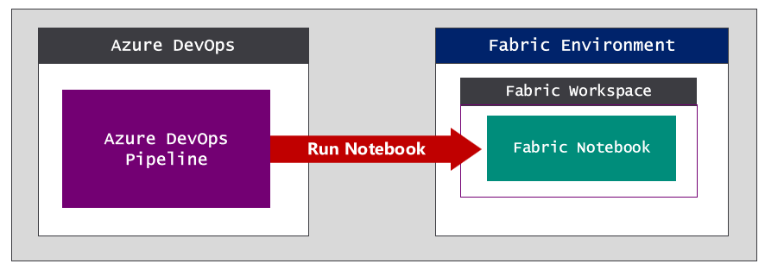\
Links for Semantic Link Labs
- What is semantic link?
- Semantic Link Labs
- Semantic Link Labs Code Examples

Automating Infrastructure CI/CD Tasks with Terraform
Terraform is an open-source tool built on the CI/CD principle of infrastructure as code (IaC). Terraform lets you define and set up the infrastructure for a Fabric CI/CD project using configuration files rather than ad hoc code or manual processes. Terraform makes it possible to define the infrastructure setup as code for resources such as servers, networks and databases. Once the infrastructure setup has been defined in code, it can be version-controlled, automated, and managed consistently across different environments.
Terraform has become an industry standard for provisioning Azure resources such as storage accounts, Azure SQL database and Azure Key Vault. Given that a Fabric capacity is an Azure resource, Terraform provides a good fit for provisioning capacities at the start of a Fabric CI/CD project.
Microsoft has created a Fabric Provider for Terraform that makes it possible to script out provisioning instructions to create tenant-level items in Fabric such as workspaces, connections, gateways and deployment pipelines. The ability to define and version code to provision tenant-level items provides a valuable compliment to Fabric GIT integration which only provides support at the level of the workspace item.
Resources for Terraform
- Terraform Documentation
- Terraform on Azure documentation
- Microsoft Fabric Provider

Getting Started with the Fabric REST APIs
Fabric CLI and Fabric Link Labs were both created to simplify automation in Fabric . Both have become very popular because they provide a productivity-oriented façade on top of multiple Microsoft APIs. However, some developers and development teams prefer full control over simplicity. This is especially true for experienced developers who are familiar with Entra Id authentication and executing HTTP requests against REST API endpoints. Calling directly to public APIs such as the Fabric REST API provides the great amount of flexibility and control.
The Fabric REST APIs were designed with open standards which make it accessible from a wide variety of development platforms and programming languages. The architecture of the Fabric REST APIs is built upon three fundamental concepts which are paginated results. long-running operations and throttling. Developers who begin working with the Fabric REST APIs must understand these three essential concepts in order to write code that is correct, efficient and reliable.
Fabric REST APIs that return list-based results implement a pattern known as paginated results. The motivation for paginated results is the need to avoid passing too much data across the network at once. For example, an API call might request a list that is too large to pass back to the caller in a single response body. The paginated results pattern allows an API endpoint to pass data to the caller in smaller chunks (i.e. pages). The use of paginated results improves the performance and efficiency of API calls, especially when dealing with a large amount of data.
Fabric REST APIs that run asynchronously implement a pattern known as long-running operations. An API call that runs as a long-running operation returns a status code of 202 Accepted to indicates that a job (i.e operation ) to be completed is queued up and will run sometime in the future. The caller who receives a 202 Accepted response is responsible to take additional steps to monitor the operation’s progress and to retrieve the final result when a long-running operation completes.
Fabric REST APIs enforce throttling to maintain optimal performance and reliability. Fabric throttling behavior limits the number of API calls which can be executed by a caller within a 60-second time window. Once a caller has reached the throttling limit in a specific time window, future calls in the same window will be rejected with a status code of 429 Too many requests. Fabric REST API calls which return a 429 error will include the Retry-After response header. The value of the Retry-After header tells the caller how many seconds to wait before a new time window begins when the call can be resubmitted.
Microsoft offers Software Development Kits (SDKs) for the Fabric REST APIs to .NET developer and to Python developers. These SDKs provides a significant productivity boost to developers by hiding many of the tedious and low-level details of HTTP executing HTTP requests such as passing access tokens and converting back and forth from JSON to strongly-typed .NET objects. These SDK also provide support to seamlessly deal with paginated results, long running operations and throttling error behind the scenes.
Fabric REST API Fundamentals
- Pagination
- Long running operations
- Throttling
- .NET SDK
- Python SDK (no link yet - hoping these will be a link by January 2026)

Programming with Item Definitions
Programming directly against the Fabric REST APIs is powerful because it provides full control when creating and updating workspace items. This style of programming might be tricky at first because you must learn how to update item definition files and how to pass an item definition across the network. Once you get over these hurdles, you will find that this style of programming yeilds the greatest level of control.
There are three primary scenarios in which you program directly with item definitions. First, you can pass an item definition when calling the Create Item API. Second, you can update an existing item by passing an item definition in a call to the Update Item Definition API. Third, you retrieve the item definition for an existing item by calling the Get Item Definition API.
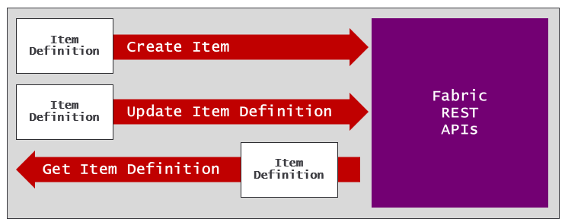
Let's walk through a scenario in which creating a workspace item requires updating an item definition file. In this scenario, imagine you have just used the Fabric REST API to create a workspace and a lakehouse inside tht workspace. Now it's time to create the notebook. However, you have to create a notebook in such a way that it's configured to use the lakehouse as its default lakehouse.
A notebook item definition requires one file named notebook-content.py in additon to the platform file.
The notebook-content.py file has metadata at the top which tracks the configuration of its default lakehouse. This metadata is hidden from the user when a notebook is opened in Fabric notebook editor. However, you can view this metadata by examining the notebook-content.py file as shown in the following screenshot.
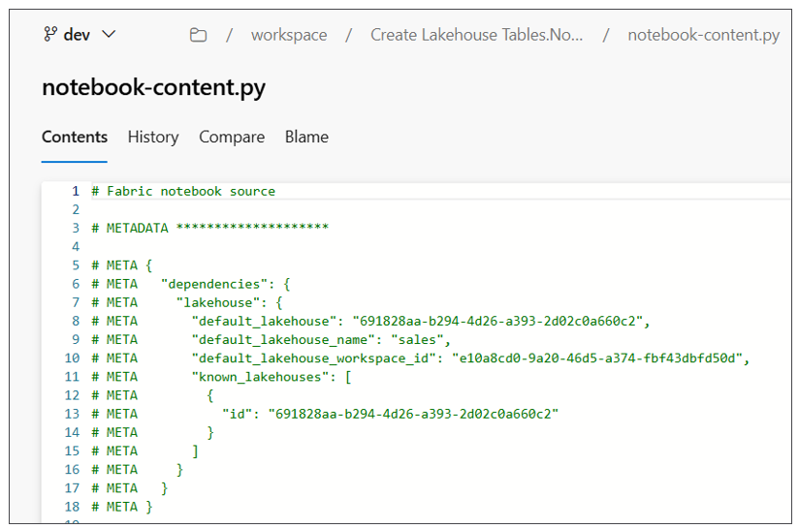
The problem is that you need to update notebook-content.py with the correct workspace id and lakehouse id. First, you need to track the ids that are generated by Fabric when you create the workspace and the lakehouse. After that, you need to perform some type of search-and-replace operation to substitute the workspace id, lakehouse id and lakehouse name into the content of notebook-content.py.
# Synapse Analytics notebook source

# METADATA ********************

# META {
# META "synapse": {
# META "lakehouse": {
# META "default_lakehouse": "{LAKEHOUSE_ID}",
# META "default_lakehouse_name": "{LAKEHOUSE_NAME}",
# META "default_lakehouse_workspace_id": "{WORKSPACE_ID}",
# META "known_lakehouses": [{ "id": "{LAKEHOUSE_ID}" }]
# META }
# META }
# META }
Once you have updated the contents of notebook-content.py, the next thing you need to do is to pass item definition files across the network when calling to the Create Item API. The next problem you encounter is how to pass multiple files across the network in an HTTP request body. The answer to this problem is to format the content of each file using base64 encoding.
When you format the contents of a item definition file with base64 encoding, you can add that encoded content in a JSON element as a string value. This makes it possible to transmit all the files for an item definition in a call the Create Item API.
{
"displayName": "Create Lakehouse Tables",
"type": "Notebook",
"definition": {
"parts": [
{
"path": ".platform",
"payload": "********************BASE64-ENCODED-FILE-CONTENT"********************"
"payloadType": "InlineBase64"
},
{
"path": "notebook-content.py",
"payload": "********************BASE64-ENCODED-FILE-CONTENT"********************"
"payloadType": "InlineBase64"
}
]
}
}
Now consider another scenario in which you want to update an existing workspace item. Perhaps you'd like to redirect the default lakehouse for existing notebook from one lakehouse to another. You can accomplish this using the following steps.
- Call Get Item Definition to retrieve current item definition
- Extract the notebook-content.py file content and convert it from base64 to plain text
- Perform substitution on the notebook-content.py file contents to update the workspace id and lakehouse id
- Convert the updated file contents for notebook-content.py back into the base64 encoded format
- Call Update Item Definition passing updated item definition.
Directly manipulating item definition files is a powerful technique that assumes you know what you are doing. If your update to an item definition file results in invalid syntax, you will experience errors calling Create Item or Update Item Definition.
Resources for working with item definitions
- Fabric item definitions overview
- Create Item API
- Get Item Definition API
- Update Item Definition API

Developing Fabric CI/CD Workflows
Now that you've seen your options for how to write the code for Fabric CI/CD tasks, the next question is where to deploy that code. The answer to this question is simple. You want to deploy and run your code in the same GIT repository that holds the item definitions. The next two sections will introduce the topic of hosting custom code in Azure DevOps and GitHub.

Developing Azure Pipelines
Azure DevOps is a Microsoft cloud platform that provides a suite of development tools for software teams to plan, build, test, and deploy applications. It's designed with CI/CD features to support the entire software development lifecycle. When you create a new project in Azure DevOps, the project is automatically created with a GIT repository of the same name. For example, creating a project named Project1 will automatically create a repository named Project1. In many scenarios, the GIT repository that's created along with the project is all you need. However, you can always add other repositories to a project if it's needed.
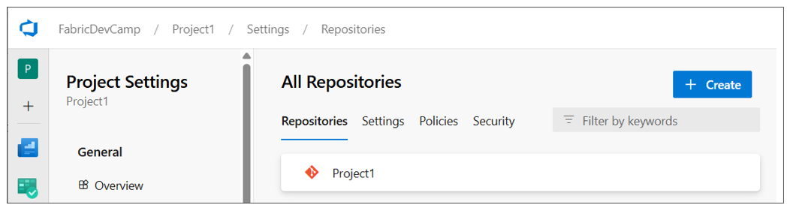
Azure Pipelines is the CI/CD workflow service that's built into Azure DevOps. Azure pipelines service provide features to integrate, test and deploy code using the principals of CI/CD. An Azure pipeline can be configured to run on-demand or on a schedule such as every night at midnight. Alternately, you can define an Azure pipeline with a trigger to run automatically in response to a code commit or the completion of a pull request.
To create an Azure pipeline, you must first add a YAML file into your repository. Once you have added the YAML file, you must then explicitly register it with the Azure pipelines service. This can be accomplished through the Azure DevOps user interface or it can be automated using the Azure DevOps CLI or the Azure REST APIs. Once a pipeline has been registered, you should be able to see it in the Pipelines page in an Azure DevOps project.
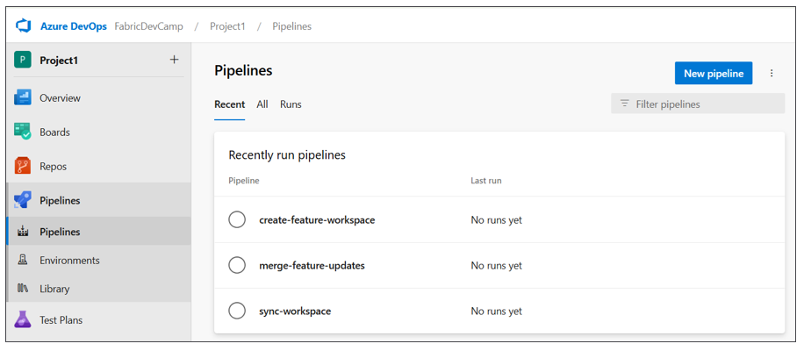
You can write the code for an Azure pipeline in a programming language such as PowerShell or Python. This is accomplished by referencing the script with the code from the YAML file. The following screenshot shows an example of three YAML files for three Azure pipelines in the .pipelines folder and their associated Python scripts in the src folder. Below these two folders you can also see the workspace folder which contains the item definitions for a specific workspace.
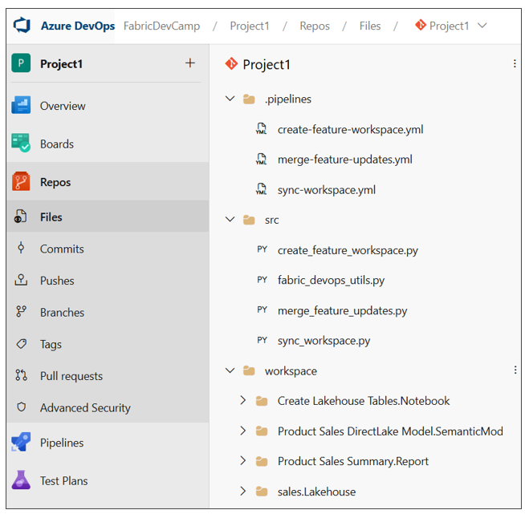
As you begin to develop Azure pipelines for a Fabric CI/CD project, you will find you need some way to track environment settings such as the ids for workspaces, capacities, users and groups. You might also need authentication credentials for an Entra Id application so your code can authenticate as a service principal. The Azure pipelines service allows you to create variables to track these types of environment settings.
In order to create variables for use in Azure pipelines, you must first create a variable group. Once you have created a variable group, you can then add a set of named variables along with their values. The following screenshot shows the typical set of variables created for Azure pipelines in a Fabric CI/CD project.
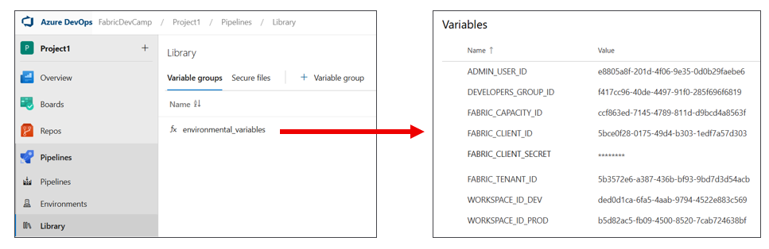
When you create a variable that contains sensitive data, you can mark that variable as a secret. For example, your pipeline might need to access to a client secret used to authenticate as a service principal. When you mark a variable as a secret, the Azure pipelines service does several important things to protect its value. First, the variable is persisted in the cloud using an encrypted format rather than plain text. Second, the value cannot be viewed in the Azure DevOps UI after saving. Third, the secret value is masked in logs. If the secret value appears in pipeline output, Azure Pipelines replaces it with *** so it won't be visible in build logs.
Variable groups in Azure DevOps can also be integrated Azure Key Vault. That means you can configure access to secrets in Azure Key Vault from code running in an Azure pipeline. This makes it possible to benefit from Azure Key Vault features such as conditional access policies, auditing, and secret rotation.
By default, an Azure pipeline does not have access to the variables in a variable group. Instead, you must configure permissions for a variable group to ensure your Azure pipelines you create have access to variables and secrets. These permissions can be configured using the Pipeline permissions dialog in the Azure Devops user interface or by using the Azure DevOps CLI or the Azure REST APIs.
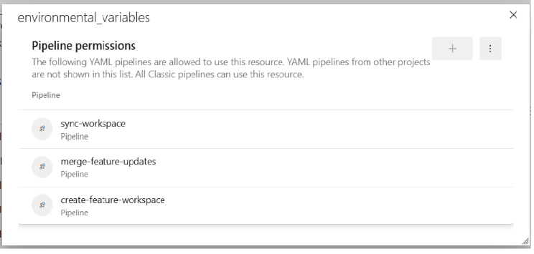
As you begin to developer Azure pipelines, you will want to become familiar with monitoring pipeline runs in order to test and debug your code. It's important to add logging to your code to report on successful operations as well as errors that occur. The following screenshot shows how an Azure pipeline can be written to log it progress in a Fabric CI/CD workflow.
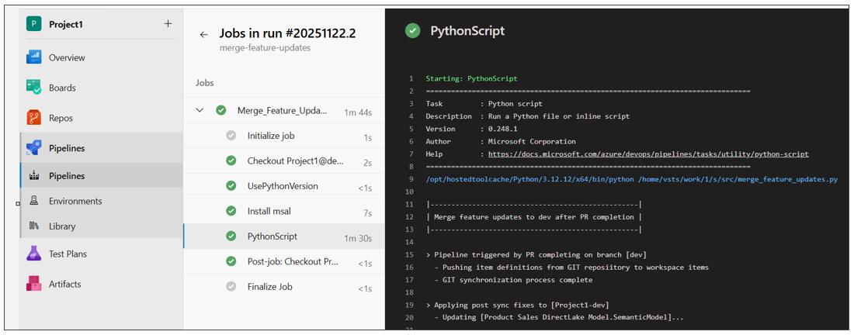
Azure DevOps Pipeline Resources
- Azure Pipelines documentation
- Key concepts
- YAML pipeline editor
- Manage variable groups
- Use Azure Key Vault secrets in Azure Pipelines

Developing GitHub Workflow Actions
GitHub is different from Azure DevOps with respect to how you work with projects and repositories. GitHub allows you to create repositories without first creating a project. While GitHub supports creating projects to assist with organizing repositories, the use of projects in GitHub is optional. When using GitHub as the GIT provider for a Fabric CI/CD project, you just need to create a repository to get started.
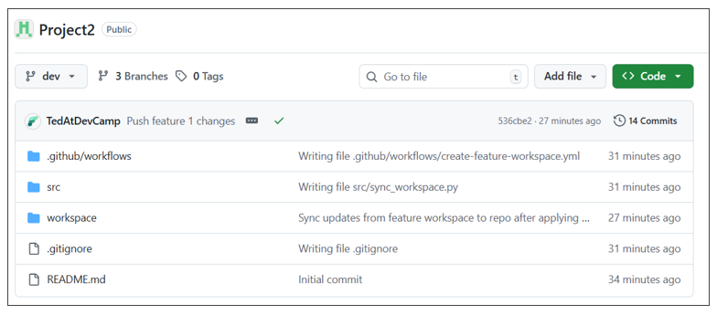
GitHub Actions is the CI/CD platform in GitHub that allows you to automate build, test, and deployment pipelines. You can create GitHub actions workflows that can be run on-demand or run on a schedule. You can also configure workflows to run in response to events such as a code commit or the completion of a pull request.
With GitHub Actions, you create a workflow by copying a YAML file into a special system folder named .github/workflows. Unlike Azure pipelines, there is no need to register the YAML file with GitHub. Just coping to file into the .github/workflows folder is all you need to do. Inside the YAML file, you can reference a script written in a language such as PowerShell or Python. The following screenshot shows all the files for a Fabric CI/CD project in a GitHub repository.
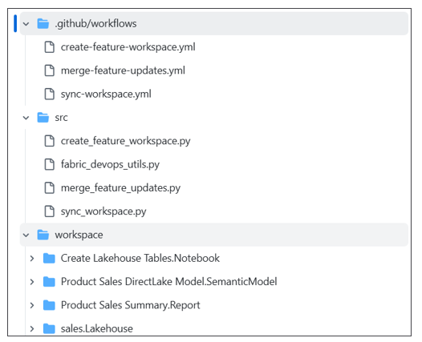
As you begin to develop Git Actions workflows for a Fabric CI/CD project, you need a way to track environment settings such as the ids for workspaces, capacities, users and groups. Your code might also need authentication credentials to authenticate as a service principal. GitHub allows you to create secrets and variables to track these types of environment settings.
You can view and create secrets by navigating to Settings page for a repository and then selecting the Secrets and variables > Actions link in the left navigation. When you create a secret, GitHub will encrypt its value and redact it from logs. A GitHub Action workflow decrypts a secret at runtime, injected into your workflow, then immediately discards from memory when the workflow completes.
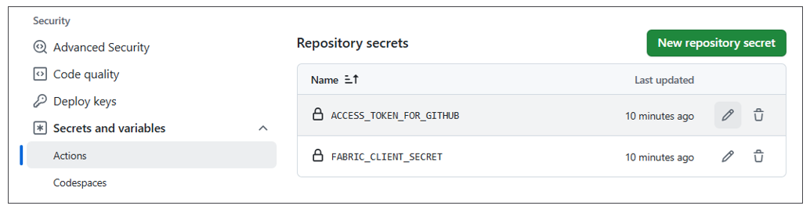
You can also add variables to a GitHub repository for environment settings that are not sensitive. The following screenshot shows the typical set of variables created for Azure pipelines in a Fabric CI/CD project.
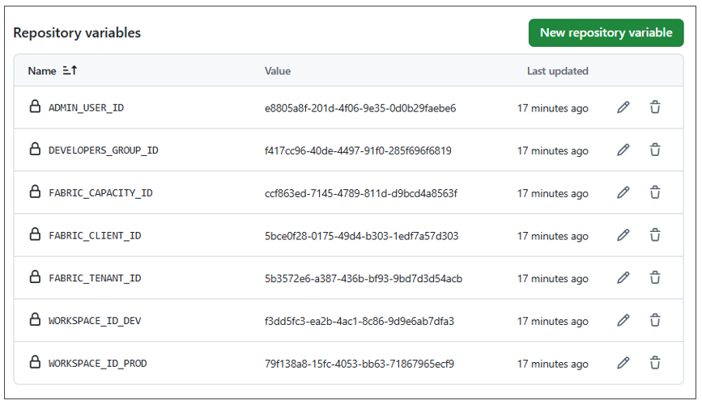
While you can create secrets and variables at the repository level, you can achieve greater levels of granularity by using environments to a GitHub repository. Consider a scenario where some workspaces in a Fabric CI/CD project exist within different Entra Id tenants. For example, imagine there are three different Entra Id tenants for dev, test and prod. In this scenario, you will need different authentication credentials for each Entra Id tenant.
You can start by creating three different environments for dev, test and prod.
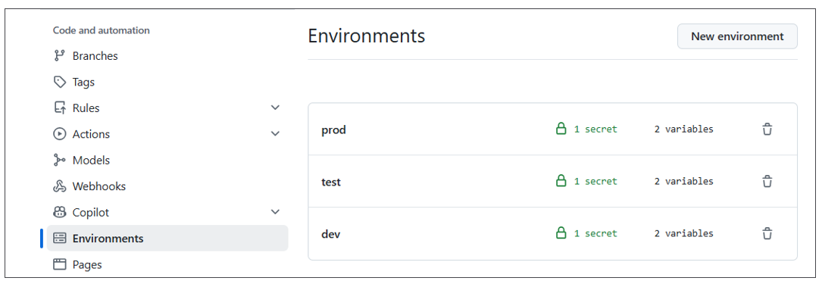
After that, you can configure each environment with the authentication credentials specific to its Entra Id tenant.
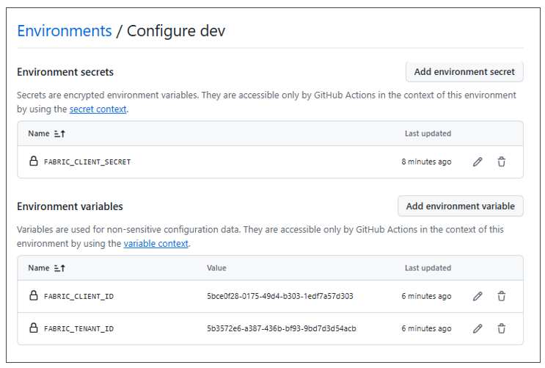
Once you have added the YAML file for a GitHub Actions workflow into the .github/workflows folder, you can view that workflow in the left navigation of the Actions page. You can select a workflow to drill down see its run history.
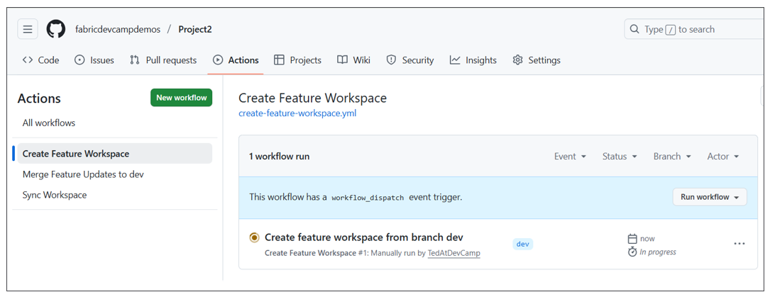
After selecting a workflow in the left navigation, you can run it on demand by dropping down the Run workflow menu and clicking the Run workflow button. If you need to collect information from the user running the workflow, you can define input fields in the workflow's YAML file. The following screenshot shows an example of a workflow that defines input parameters for a textbox and two checkboxes.
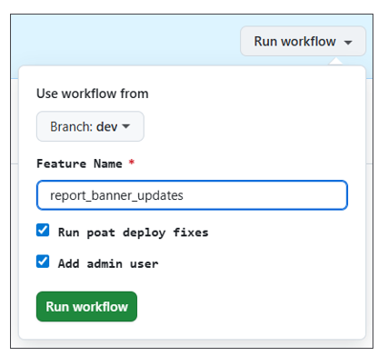
As you begin to develop workflows with GitHub Actions, you will want to become familiar with monitoring workflow runs in order to test and debug your code. It's important to add logging to your code to report on successful operations as well as errors that occur. The following screenshot shows how an Azure pipeline can be written to log it progress in a Fabric CI/CD workflow.
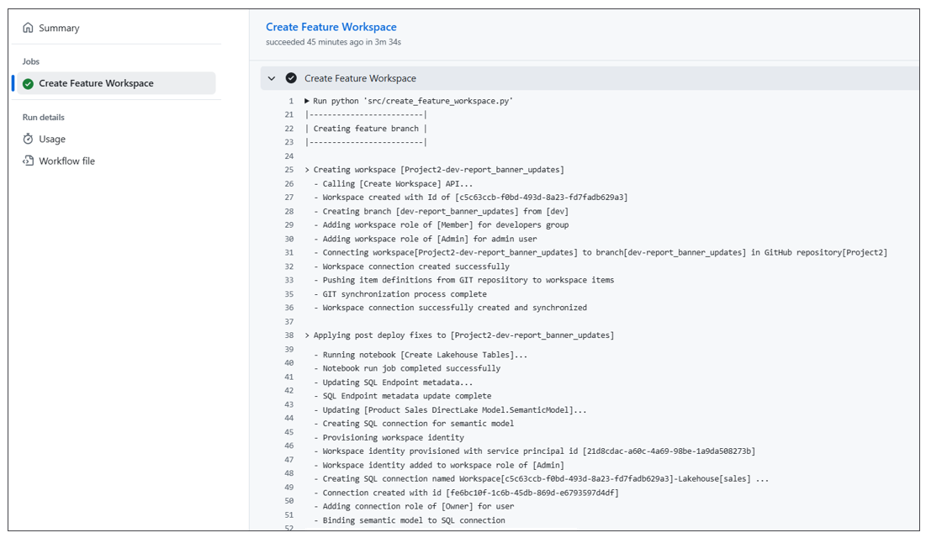

Summary
Yada yada

